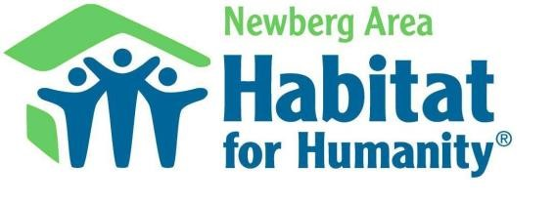

**Family Selection Criteria**

# Connection To Newberg Habitat for Humanity Service Area

* Family lives, works, or has some specific connection to the Newberg Area Habitat service area, which consists of the following towns: Newberg, Dayton, Dundee, Sherwood, St. Paul.

# Need For Adequate Shelter

* Current shelter has problems with heating, water, electricity, bathroom(s), kitchen, structure, environmental hazards, etc.
* Overcrowded conditions determined by the number of persons, age, and sex of family members.
* Unable to obtain a conventional or government assisted loan.
* Excessive amount of income spent on housing.
* Special needs of family member that cannot be met in current living circumstances.

# Ability To Pay

* Family has a reliable source of income.
* Family demonstrates the financial resources and ability to pay the monthly payment (including taxes and insurance) on a regular basis. Home ownership must not threaten household income or the ability to continue payments of monthly household expenses and/or current debt.
* Family has a history of responsible payment of debt
* Family’s total gross annual income is not less than 25% and no greater than 60% of the median income of Yamhill County for their family size. (For 2023, the income range is $28,208 to $67,680 for a family of four.) Exceptions may be made for exceptional need.
* The combined total of the monthly mortgage payment and all monthly debt payments should not be greater than 36% of the family’s gross monthly income. Exceptions in severe cases of need.

# Willingness to Partner With Habitat for Humanity

* Family understands 500 hour sweat equity requirements and its demands and is willing to complete 100 hours before work begins on their own home and is willing to complete a minimum of 500 hours (250 hours with specified assistance from friends, neighbors, and community volunteers) prior to taking possession of their home.
* Family is willing to attend Habitat’s Family Support classes, which include financial counseling, home maintenance, and repairs.
* Family is willing to receive home visits and interviews from family selection committee member(s) and media representatives for publicity purposes. Most importantly, the family desires to be active participants in Habitat, helping others achieve home ownership by volunteering their time and continuing the circle of “a hand up.”

*Newberg Area Habitat for Humanity does not discriminate based on age, sex, race, color,*

*ethnic background, national origin, religion, marital status, or sexual orientation.*

***5/2/2024***

***Newberg Area Habitat for Humanity***

***PO Box 118***

***620 N Morton***

***Newberg, Oregon 97132***

***Office: 503-537-9938 Email: info@newberghabitat.org***

***Newberg Area Habitat for Humanity***

***Median Income: $106,948\****

## Income Limits -2023

|  |  |  |  |  |  |  |  |
| --- | --- | --- | --- | --- | --- | --- | --- |
| 1  Person | 2  Persons | 3  Persons | 4  Persons | 5  Persons | 6  Persons | 7  Persons | 8  Persons |
| 19,750 | 22,583 | 25,417 | 28,208 | 30,500 | 32,750 | 35,000 | 37,250 |
| 47,400 | 54,180 | 60,960 | 67,680 | 73,140 | 78,540 | 83,940 | 89,340 |

Percentage of

Median Income

25%

60%

*Source: HUD Guidelines 2023

*Newberg Area Habitat for Humanity does not discriminate based on age, sex, race, color,*

*ethnic background, national origin, religion, marital status, or sexual orientation.*

***5/2/2024***